**.NET Application Programming**

**Project Status and Design Report**

|  |  |  |
| --- | --- | --- |
| **Topic:** | *FR4, FR4.5* | |
| **Date:** | *10-01-2020* | |
| **Revision:** | *3.0* | |
| **Team:** | 1. *Matt Sievers* | |
| 1. Crystal Sciarrino | |
|  | |
|  | |
| **Weekly Team Status Summary:** | |  |  |  |  | | --- | --- | --- | --- | | **User Story** | **Team**  **Member** | **Hours**  **Worked** | **Hours Remaining** | | As a developer, I need to update the registration page password to show *** | *Crystal Sciarrino* | *2* | *0* | | As a team, the weekly team paperwork deliverables need to be completed | *Matt Sievers / Crystal Sciarrino* | *2* | *1* | | As a developer, I need to update the Login page password to show *** | *Crystal Sciarrino* | *2* | *0* | | As a developer I need to create the board model | *Matt Sievers* | *1* | *0* | | As a developer I need to create the cell model | *Matt Sievers* | *1* | *0* | | As a developer I need to create the GameBoardController (GBC) | *Matt Sievers* | *4* | *0* | | As a developer I need to add validation to the models for entry on the registration page | *Crystal Sciarrino* | *4* | *0* | | Ass a developer I need to add validation to the models for entry on the Login page | *Crystal Sciarrino* | *2* | *0* | | As a developer, I need to update GBC to populate and build the game board into a 2d array to use in a table on the view | *Matt Sievers* | *2* | *0* | | As a developer, I need an OnClick() method to help determine which button was clicked on the game board. Add simple logic to add a bomb image for live==true and if not show neighbors value (if 0 "") | *Matt Sievers* | *2* | *0* | | As a team, we need to create week 3 user stories | *Matt Sievers / Cryatal Sciarrino* | *1* | *0* | | As a developer, I need a new folder to house images used for the game | *Matt Sievers* | *1* | *0* | | As a developer I need a new view created to select difficulty. Three buttons, easy, moderate, hard are required to set the game board live cells. | *Matt Sievers* | *1* | *0* | | As a developer, I need to add the DifficultyClick() to GBC. | *Matt Sievers* | *2* | *0* | | As a developer, I need to update the workflow so that the registration and login pages land on the right pages now. Registration -> Login -> Difficulty | *Crystal Sciarrino* | *1* | *0* | | As a developer, I need to remove un needed views. | *Crystal Sciarrino* | *1* | *0* | | |
| **GIT URL:** | https://github.com/Malleas/CLCMinesweeperApp | |
| **Peer Review:** | *Y/N* | We acknowledge that our team has reviewed this Report and we agree to the approach we are all taking. |

**Planning Documentation**

**Agile Scrum Board:**

[**https://www.meistertask.com/app/project/sSO4jU4u/cst-247**](https://www.meistertask.com/app/project/sSO4jU4u/cst-247)

**Agile Scrum Product Backlog:**

<https://github.com/Malleas/CLCMinesweeperApp/tree/master/CLCMinesweeperApp/Planning%20and%20Design/Week%202>

**Agile Scrum Sprint Backlog:**

[*https://github.com/Malleas/CLCMinesweeperApp/tree/master/CLCMinesweeperApp/Planning%20and%20Design/Week%202*](https://github.com/Malleas/CLCMinesweeperApp/tree/master/CLCMinesweeperApp/Planning%20and%20Design/Week%202)

**Agile Scrum Burn Down Chart:**

[*https://github.com/Malleas/CLCMinesweeperApp/tree/master/CLCMinesweeperApp/Planning%20and%20Design/Week%202*](https://github.com/Malleas/CLCMinesweeperApp/tree/master/CLCMinesweeperApp/Planning%20and%20Design/Week%202)

**Agile Retrospective Results:**

*The following table should be completed after each Retrospective on Things That Went Well (Keep Doing). An alternative to the following table is to use a Mind Mapping tool such as Coggle. If you use a Mind Mapping tool you must include a URL or Image File.*

|  |
| --- |
| **What Went Well** |
| **Able to get the DB working locally and save/validate data** |
| **Able to share the code between team members** |
|  |

*The following table should be completed after each Retrospective on Things That Didn’t Go Well (Stop Doing) and What Would Be Done Differently Next Time with an Action Plan to Improve (Try Doing and Continuous Improvement). An alternative to the following table is to use a Mind Mapping tool such as Coggle. If you use a Mind Mapping tool you must include a URL or Image File.*

|  |  |  |
| --- | --- | --- |
| **What Did Not Go Well** | **Action Plan** | **Due Date** |
| Unable to get DB working on Crystals system locally | Look for a hosted solution, possibly Azure. | **10/10/20** |
| **Initial project created by Crystal was a ASP.NET Core app and not a web app, some refactoring into the right project type was needed** | **None, discussions were had between team members and changes were made to the project.** |  |
|  |  |  |

**Design Documentation**

**Install Instructions:**

*Connect and pull from master from repo. Refer to DDL scripts before running as a local DB will need to be created and table added. Click debug menu option and select Run without debug*

**General Technical Approach:**

*We as a team wanted to make sure that the login and registration pages were simple to use and met all requirements listed. We also wanted to add some basic validation in on the login and createUser to ensure the userName and password for login matched as well as the createUser was able to insert the data into the localDB.*

**Key Technical Design Decisions:**

*Reuse the SecurityService and SecurtiyDAO from assignment 1 for the login page as well as create a new UserService to house all user related queries such as createUser or possibly later updateUser.*

**ER Diagram:**

*n/a for this requirement*

**DDL Scripts:**

*CREATE TABLE [dbo].[Player]*

*(*

*[USERID] INT NOT NULL PRIMARY KEY IDENTITY(1,1),*

*[FIRSTNAME] VARCHAR(50) NOT NULL,*

*[LASTNAME] VARCHAR(50) NOT NULL,*

*[GENDER] VARCHAR(50) NOT NULL,*

*[AGE] INT NOT NULL,*

*[STATE] VARCHAR(2) NOT NULL,*

*[EMAILADDRESS] VARCHAR(100) NOT NULL,*

*[USERNAME] VARCHAR(50) NOT NULL,*

*[PASSWORD] VARCHAR(50) NOT NULL*

*)*

**Sitemap Diagram:**

*N/A not required for this FR*

**Security Design:**

*Not needed till FR-4 but as stated above for key technical decisions, we should work on SOP for passwords.*

**Third Part Interface Design:**

*NA*

**Flow Charts:**

*NA*

**User Interface Diagrams:**

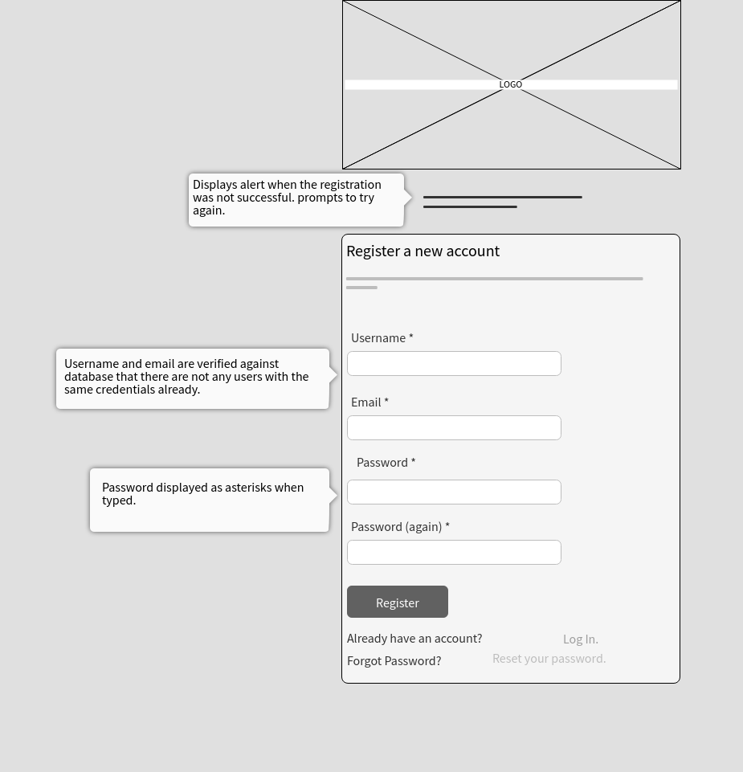

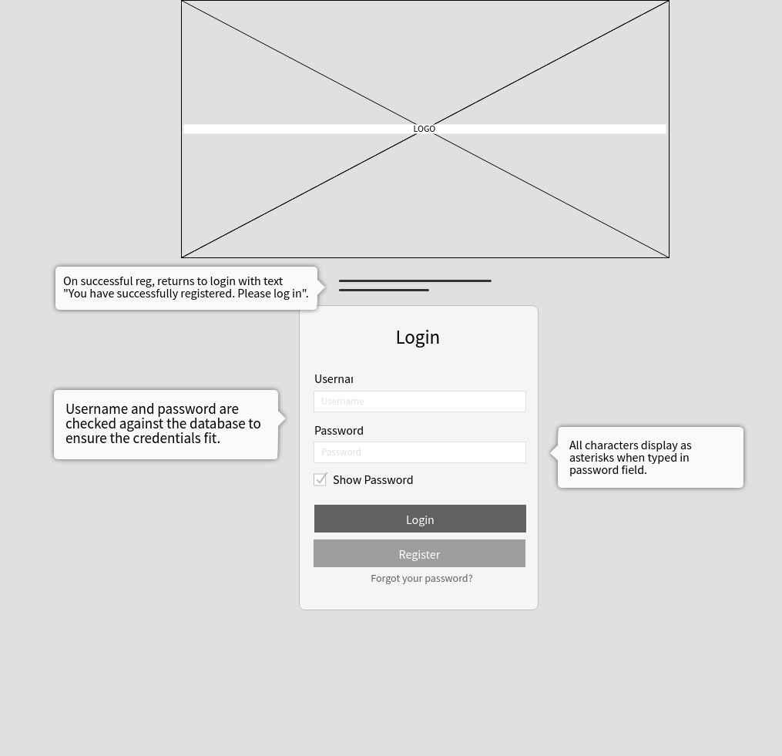

**Class Diagrams:**

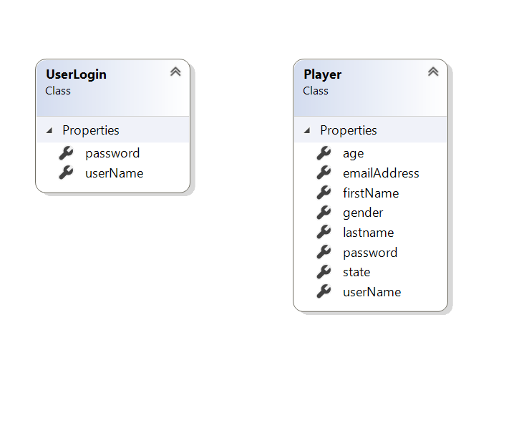

**Pseudo Code:**

*N/A*

**Other Documentation:**

*N/A*